COURSE SYLLABUS
Bus. 301.4 OA
Building Relationships for Business
Spring 2023 Online Asynchronous (OA)

Course Information

Instructor Information
Instructor | Dr. Reed Stratton (you can call me “Professor Stratton”)
Office | CPS 216 & Online Via Zoom (Password: Audience)
Office Hours | Monday: 11:00am-3:30pm  Tuesday: 12:00pm-3:30pm  Wednesday: By appointment  Thursday: Online 7:00am-9:00am  Friday: Online 7:00am-9:00am
Cell Phone | 507-304-0223
E-mail | Reed.stratton@uwsp.edu
Expected Instructor Response Time | 24 hours if contacted Monday-Friday  72 Hours if contacted Saturday, Sunday
Format | Online Asynchronous- Complete work on Your Own Weekly

Course Information
Course Description: | Study and practice strategies of interacting with others in business, in internships, and after graduation. Acquire and practice in-demand interpersonal skills in business such as collaboration, leadership, networking, negotiation, cross-cultural awareness, conflict management, giving and receiving feedback, and self-awareness. Apply communication theory to concrete, contextualized interpersonal communication activities and projects.
Credits: | 3
Prerequisites: | Bus. 325

Textbook & Course Materials
Required Text: | The Harvard Business Review Guide to Persuasive Presentations  Handbook for Early Career Success
Other Readings: | Supplemental readings posted on Canvas
Other Required Materials | Computer, Tablet, or Smartphone  Web Cam  Microphone

Learning Outcomes

SBE Mission
The UW-Stevens Point School of Business and Economics creates career ready graduates and leaders through applied learning. We serve the businesses, economy, and people of the greater Central Wisconsin region. We specialize in preparing students for success by providing professional development experiences, access to employers, and in-demand skills.

The SBE achieves its mission by valuing:
- Talent development
- Lifelong learning
- Career preparation
- On the job experiences
- Community outreach
- Regional partnerships
- Continuous improvement

Course Goals for professionalism and effective communication
M Most SBE courses achieve the SBE Mission through knowledge-based instruction. Those courses teach what you must know as a business professional, and you demonstrate that you know what you're supposed to know through exams and assignments. However, BUS 301 focuses more on the last two missions: professionalism and effective communication. The objective of this course is to help you expand your awareness and comfort zone during professional interactions, so you can become more deliberate and strategic in your communication approach. Therefore, BUS 301 is behavior-based, emphasizing what you can do more than what you know. These behaviors include:

• Conveying passion • Managing ambiguity
• Relationship building • Problem solving
• Analyzing • Strategizing
• Storytelling • Being self-aware
• Personal branding • Perspective taking (what others think)
• Pursuing intellectual curiosity • Empathizing (what others feel)
• Practicing humility • Being open to differences
• Taking calculated risks

Course Learning Outcomes
Given my goal of emphasizing the above behaviors, by the end of this class, you will be able to…
Connect
- build trust with valuable business connections through interpersonal communication strategies
- anticipate and incorporate diverse perspectives into communication.
Sell Your Value/Persuade
- express your value to an organization in an interview to influence hiring, promotion, and buy-in
- understand the four steps of persuasion and apply them to influence your audience
Present
- apply strategies for smooth, authentic, and professional online presentations in business
- create credible, engaging messages that appeal to audience interests

Grading

Grading Structure
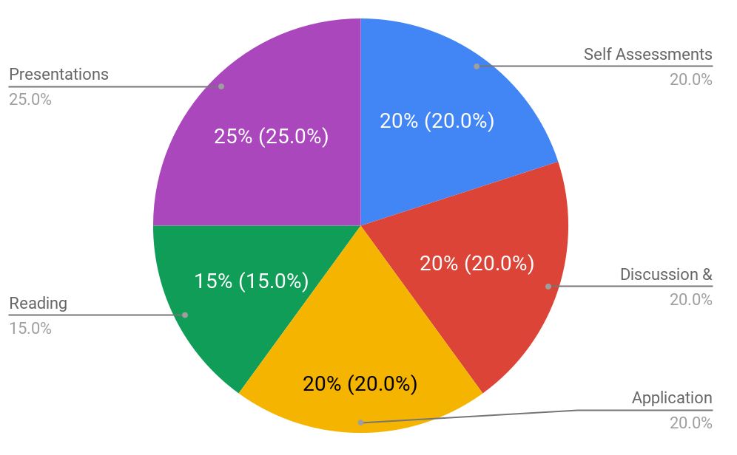 | 93-100% A 78-79% C+ 62-60% D-  90-92% A- 73-77% C ↓59% F  88-89% B+ 70-72% C-  83-87% B 68-69% D+  80-82% B- 63-67% D

Coursework

Pro Events
Several UWSP departments and programs, including the School of Business & Economics, sponsor Smiley Professional Events (or Pro Events).
Pro Events connect you to:
· Campus (e.g., academic coaching, student clubs);
· Community (e.g., Rotary, Business Council): and
· Careers (e.g., internships, networking).
As an SBE student, you will be able to choose from a wide variety of speakers, workshops and special events. With over 300 events per year on the Pro Events calendar, you will have significant flexibility in selecting your events. Whatever you choose, Pro Events will help you to make the most out of your time as a student and to prepare for transitioning into a successful career.
Visit the Pro Events web site (proevents.uwsp.edu) for announcements of upcoming events. You can also follow us on social media. Facebook: UWSP School of Business & Economics Twitter: @UWSPBusiness
For this course, you must attend two official Pro Events. One event must be before the mid-semester cut-off of ____; a second event must be before the end-of-semester cut-off of _____. If you go to extra events before the mid-semester cut-off, those credits will carry over into the second half of the semester.
You may earn Pro Events credits in many different ways:
· “Attending” live Zoom events; attendance will be taken at the end of the event.
· Attending in-person events.
· For maximum schedule flexibility, check out the Anderson Center Canvas page for details on Create Your Own events and Lunch with a Leader.
Starting Fall 2022, only students registered for 100% online or branch-campus classes will have access to Pro Events recordings. The number of videos available will be pro-rated based on the number of such courses in which you are enrolled. Video events must be completed one week before the general Pro Events cut-offs.
Attendance at Pro Events will be confirmed with automatic emails to you and updated on the Pro Events web site. Please allow a week for confirmation of attendance at events held outside the SBE, such as Career Services events. If you have a question about Pro Events attendance, please email proevents@uwsp.edu .
If you have multiple courses or affiliations with Pro Events requirements, it is your responsibility to make sure you have attended enough events for each course/affiliation. If you have not attended enough events to cover all of your requirements, your attendance will be allocated to your courses in alpha-numeric order followed by any other affiliations.
After the mid-semester cut-off and the end of this semester’s events, I will receive reports confirming your attendance. You do not need to do anything else.
Hint: if you are having trouble finding events that fit your schedule, check out the “Create Your Own Event” option on the Anderson Center Canvas page. You can meet with an expert from Career Advising, Financial Coaching or Academic Coaching. We also highly recommend our “Lunch with a Leader” program which allows you to set up a lunch (virtual or in-person) with a business expert to learn more about their industry, company and profession.

Assignment Group: Self Assessments (20% of grade)
Impactful communicators know themselves. They’re aware of their own prejudices, thinking styles, strengths, and potential contributions and can articulate these things about themselves to fellow business contacts. Assignments in this category are designed to build your self-awareness and include surveys, reflections, and personality assessments.

Assignment Group: Presentations (25% of grade)
A new Linked In study indicates that employers value oral presentation skills more than all other skills. The best way to build your oral presentation skills is frequent presentations that challenge you to leave your comfort zone and practice managing your anxiety. Additionally, our business contacts are telling us that online presentations won’t go away even when (or if…) Covid 19 protocols do.

You’ll deliver four oral presentations this semester. They will be recorded via Zoom, Canvas’ recording app, Kaltura, or an app on your phone and submitted via Canvas.

Assignment Group: Reading Responses (15% of grade)
This class gives you access to the insights of the most admired, influential thinkers in the business world. They have brilliant ideas to share about sought-after skills like persuasion, authenticity, storytelling, emotional intelligence, and empathy. That’s why I assign readings.

You’ll gain the most from the readings by connecting your own experiences, ideas, insights, needs, and goals to what you’re reading through reading responses, which will be graded using this rubric. The rubric pushes you out of the lower levels of thinking which involve simple memorization and regurgitation and won’t stick with you. Research shows you won't retain concepts that you’ve merely memorized and regurgitated, which means you’ll be wasting the money you paid for this semester. However, if you engage with the material in more complex ways such as application, analysis, and evaluation you will retain it, make it your own, and be able to use it as a tool to help you land your dream career.

Assignment Group: Discussion/Participation (20% of grade)
Learning is a community process. You have powerful ideas to contribute to our group, and you have powerful insights to learn from your classmates who also, by the way, are your future business partners, clients, and collaborators. Therefore, you’ll practice sharing your thoughtful insights in this class in online discussion boards. Though not required, you are encouraged to use video discussion posts to practice sharing your ideas in-person to a video camera- a sought after skill in business.

Original discussion posts will be graded for
- Development
- Application of course concepts
- Engagement with others (response)

Discussion Responses
You’re encouraged to respond with video, but written text is okay. Unless noted, you’re required to respond to at least one of your classmates for each discussion board. Your response should deepen your classmate’s insights, contribute a new perspective, share an application from your personal life, and/or provide some kind of constructive challenge to his/her perspective.

Application Projects (20% of grade)
The disadvantage of an online class is that we don’t get to do projects together in the classroom. However, that doesn’t mean you can’t take “field trips” and do experimental projects on your own in whatever setting you’re taking the course. Since, I can’t physically see whether you’ve accomplished each project, you’ll be graded for this area on the reflections on each project that you submit to Canvas. Again, because the goal here is to take risks, experiment, and learn about yourself in the process, these projects will be graded on a pass/fail basis.

Course Policies

Late Work
In the marketplace, completing written and oral reports on time makes you a valuable contributor, and it helps convince your organization you’re indispensable. On-time submission can increase your odds for promotions and leadership roles because it builds trust, a crucial human need.

I’m strict about deadlines because I want those making decisions about your career to trust you. Therefore, practice submitting on time now. Late submissions will be graded this way:

- Submitted up to 1 day (10 mins to 24 hours) after deadline= 5% reduction in grade
- Submitted 2 days (25-48 hours) after deadline= 10% reduction in grade
- Submitted 3 days (49-72 hours) after deadline= 15% reduction in grade
- Submitted 4 days (73-96 hours) after deadline= 20% reduction in grade
- Submitted 5 days + (96+ hours) after deadline= automatic 55% (F)

I may grant extensions but only if asked at least 24 hours before the deadline.

Missing Work
An assignment submitted more than 5 days (96 hours+) after the due date, not submitted at all, or not submitted properly per my requests will be considered missing. I will rarely grant extensions, but I encourage you to discuss the possibilities with me in extreme circumstances. However, I’ll only grant possible extensions if requested (usually via email) 24 hours or more before the deadline.

Plagiarism and Academic Honesty
You must use appropriate conventions for referencing words and ideas that are not your own (MLA, APA, Chicago). Representation of the thoughts or words of someone else as your own is plagiarism. UWSP takes it seriously. Plagiarism may result in failure, suspension, or even expulsion. As your instructor, I will comply with university policy and report purposeful plagiarism. If you are struggling with citation, see me or the campus writing center. We can discuss the problem and help you overcome it.

Inclusivity Statement
It is my intent that students from diverse backgrounds and perspectives be well-served by this course, that students’ learning needs be addressed both in and out of class, and that the diversity that the students bring in and out of class be viewed as a resource, strength, and benefit. Every student has a perspective, and we learn by hearing many of them, but some of your perspectives aren’t represented in our course readings, so learning depends upon you all contributing to the class with your opinions and perspectives as well.

It is my intent to present materials and activities that are respectful of diversity: gender identity, sexuality, disability, age, socioeconomic status, ethnicity, race, nationality, religion, and culture. Your suggestions are encouraged and appreciated. Please let me know ways to improve the effectiveness of the course for you personally, or for other students or student groups.

If you have experienced a bias incident (an act of conduct, speech, or expression to which a bias motive is evident as a contributing factor regardless of whether the act is criminal) at UWSP, you have the right to report it using this link. You may also contact the Dean of Students office directly at dos@uwsp.edu

Schedule

Time Commitment
Expect to commit about five hours per week to this course, which breaks down (roughly) like this:
2.5 hours/ wk | watching lectures  posting to discussion boards  completing activities
2.5 hours/ wk | preparing for presentations  taking “field trips”  reading

Other Administrative Details

ADA / Equal Access for Students with Disabilities
The American Disabilities Act (ADA) is a federal law requiring educational institutions to provide reasonable accommodations for students with disabilities. For more information about UWSP’s policies, see: https://www.uwsp.edu/datc/Pages/uw-legal-policy-info.aspx

UW-Stevens Point will modify academic program requirements as necessary to ensure that they do not discriminate against qualified applicants or students with disabilities. The modifications should not affect the substance of educational programs or compromise academic standards; nor should they intrude upon academic freedom. Examinations or other procedures used for evaluating students' academic achievements may be adapted. The results of such evaluation must demonstrate the student's achievement in the academic activity, rather than describe his/her disability.

If modifications are required due to a disability, please inform the instructor and contact the Disability and Assistive Technology Center to complete an Accommodations Request form. The Disability and Assistive Technology Center is located on the 6th Floor of Albertson Hall. For more information, call 715-346-3365 or visit: https://www.uwsp.edu/datc/Pages/default.aspx

Help Resources
The Tutoring and Learning Center helps with Study Skills, Writing, Technology, Math, & Science. The Tutoring and Learning Center is located at 018 Albertson Hall. For more information, call 715-346-3568 or visit: https://www.uwsp.edu/tlc/Pages/default.aspx

If you need healthcare, UWSP Student Health Service provides student-centered healthcare that empowers and promotes wellness for all UWSP students. Student Health Service is located on the 1st floor of Delzell Hall. For more information, call 715-346-4646 or visit: http://www.uwsp.edu/stuhealth/Pages/default.aspx

The UWSP Counseling Center is staffed with licensed mental health professionals dedicated to assisting students as they navigate difficult circumstances or resolve personal concerns. Therapy and consultation services are free of charge for registered students. The UWSP Counseling Center is located on the 3rd Floor of Delzell Hall. For more information, call 715-346-3553 or visit: http://www.uwsp.edu/counseling/Pages/default.aspx

In addition to the support services provided by Student Health Service and the UWSP Counseling, there are also professional support services available to students through the Dean of Students. For more additional information, please go to http://www.uwsp.edu/dos/Pages/default.aspx

University Drop Policy
You are expected to complete the courses for which you register. If you decide you do not want to take a course, you must follow the procedures established by the university to officially drop the course. If you never attend or stop attending a course and fail to officially drop, you will receive an F in the course at the end of the semester. A link to the university’s drop policy can be found at: https://catalog.uwsp.edu/content.php?catoid=11&navoid=431&hl=add%2Fdrop&returnto=search#Drop/Add/Withdrawal_Procedures

